Minolta A1, sold as close to new condition as a second hand camera can get – there is no sign of wear whatsoever and it comes in the original box with all the original contents.
- The 5.0 (effective) Mpixel DiMAGE A1 camera
- 16MB CompactFlash card
- NP-400 lithium-ion rechargeable battery
- Battery charger
- Neck strap
- Lens cap
- Lens hood
- USB cable
- A/V cables – Euro and UK
- 171 page camera manual + software manual (both printed)
- CD-ROM featuring DiMAGE Viewer Utility
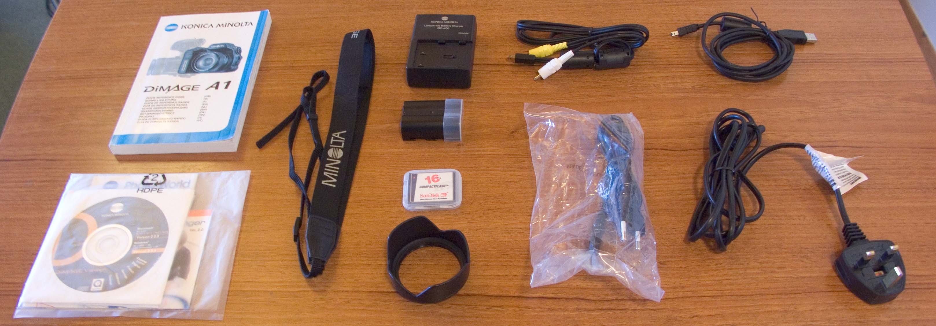

I have had the camera for 6 months and have taken very good care of it.

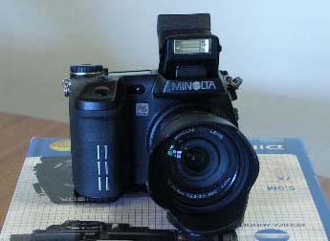
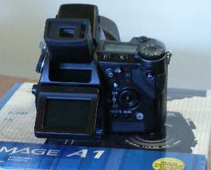

I am not really a camera “expert”, so here is a link to an independent review of the camera. http://www.dcresource.com/reviews/minolta/dimage_a1-review/

A comprehensive detailing of the camera specs can be found here http://www.jessops.com/search/viewproduct.cfm?PRODUCT=MINDA1&BRAND=&CONTINUE=false&FEATS=&FIRSTPRICE=&KEYWORD=&LEVEL=&MODELNUMBER=&NEWQUERY=True&NODE=0&ORD=ASC&ORDERBY=&QUANTITY=40&RECENT=0&REFINE=&SEARCH_FOR=a1&SEARCHNODE=0&SEARCHURL=dointellisearch.cfm&SECONDPRICE=&SHOWCASEID=&STARTROW=14&SUBS=&WORD_SEARCH=N&

If you have any further questions (as I’m sure I’ll have forgotten to mention something) then please do not hesitate to message me.

