Top of Form


  home | pay | register | register | sign out | sign in/out | services | site map
  Advanced Search
Bottom of Form

Back to My eBay
  Listed in category: | Photography > Digital Cameras > Serious (4.1 MP & Above)

 |  | MINOLTA DIMAGE A1 DIGITAL CAMERA | Item number: 3867826135

You are signed in | Email to a friend | This item is being watched in My eBay (1 item)

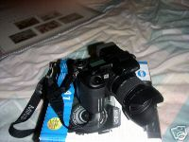
  Larger Picture
  Current bid: | £215.00  Top of Form
   | Bottom of Form
  Time left: | 20 hours 10 mins  5-day listing  Ends 21-Jan-05 16:30:53 GMT
  Start time: | 16-Jan-05 16:30:53 GMT
  History: | 20 bids (£1.00 starting bid)
  High bidder: | david_s1981 ( 246)
  Item location: | HARTLEPOOL  United Kingdom
  Post to: | United Kingdom
  Postage costs: | £14.00 - Royal Mail Special Delivery (Within United Kingdom)
  Postage, payment details and return policy
Seller information
durham50 ( 341)
Feedback Score: 341
Positive Feedback: 100%
Member since 14-Aug-02 in United Kingdom

Read feedback comments
Add to Favourite Sellers
Ask seller a question
View seller's other items

PayPal Buyer Protection
Free Coverage now up to £500. See eligibility.

 | Description |  | Seller assumes all responsibility for listing this item.

Item Specifics - Digital Cameras
 | Digital Camera Type: | Compact |  |  | Optical Zoom: | 7x
 | Brand: | Konica/Minolta |  |  | Digital Zoom: | 2x
 | Model: | DiMAGE A1 |  |  | Memory Card Format: | CompactFlash I
 | Resolution: | 5 megapixels
 | Condition: | -- |  |  | Battery Type: | Li-ion
 | Features: | -- |  |  | Bundled Kits: | --

 | 
 |  | 
  MINOLTA DIMAGE A1 DIGITAL CAMERA IN FULL WORKING ORDER AND EXCELLENT CONDITION ( NO MARKS OR SCRATCHES). COMES COMPLETE WITH ORIGINAL BOX AND KIT
  The DiMAGE A1 has an above average bundle. Inside the box, you'll find:
  - The 5.0 (effective) Mpixel DiMAGE A1 camera
  - NP-400 lithium-ion rechargeable battery
  - Battery charger
  - Neck strap
  - Lens cap
  - Lens hood
  - USB cable
  - A/V cable
  - 171 page camera manual + software manual
  - CD-ROM featuring DiMAGE Viewer Utility
  The camera is not supplied with memory, it takes compact flash or microdrives. Both formats are cheap to purchase.
  5 megapixels (effective), 7x optical zoom 28mm to 200mm)/2x digital zoom, auto and manual focus, program and auto exposure, JPEG, TIFF, and RAW file formats, ISO range 100-800, proprietary Lithium-Ion battery, movie mode with sound, Anti-Shake Function.
   |  | Select a picture
  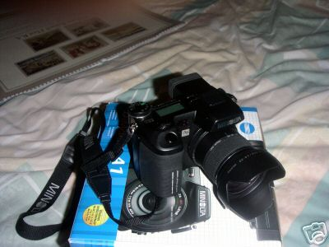
    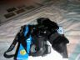 | 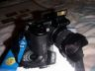
  Bottom of Form
 |  | 

 | 

Free Counters powered by Andale!

Postage, payment details and return policy

Postage Cost
Will post to United Kingdom | Services Available |  | Available to
£14.00 |  | Royal Mail Special Delivery |  | United Kingdom Only

Postage insurance
Included in postage and packing cost
Seller's payment instructions
PLEASE NOTE: BECAUSE OF THE AMOUNT CHARGED BY PAYPAL ON LARGE AMOUNT ITEMS, IF YOU WISH TO USE PAYPAL PLEASE ADD AN ADDITIONAL 2.5%.

Payment methods accepted

Personal cheque
Postal Order or Banker's Draft
Other - See Payment Instructions for payment methods accepted
Learn about payment methods.

 | Ready to bid | help

MINOLTA DIMAGE A1 DIGITAL CAMERA

Top of Form  Current bid: | £215.00
Your maximum bid:
  £ |  |  |  | (Enter £220.00 or more)
 | You will confirm in the next step.
eBay automatically bids on your behalf up to your maximum bid.
Learn about bidding.
Bottom of Form

What else can you do?
Back to My eBay | Ask seller a question | Add to Calendar | Printer-friendly page

About eBay | Announcements | Register | Safety Centre | Policies | Feedback Forum | Site Map | Help
Copyright © 1995-2005 eBay Inc. All Rights Reserved. Designated trademarks and brands are the property of their respective owners. Use of this Web site constitutes acceptance of the eBay User Agreement and Privacy Policy.

eBay official time

